1. Go to<https://login.canvas.cornell.edu/>

2. Login with Cornell NetID

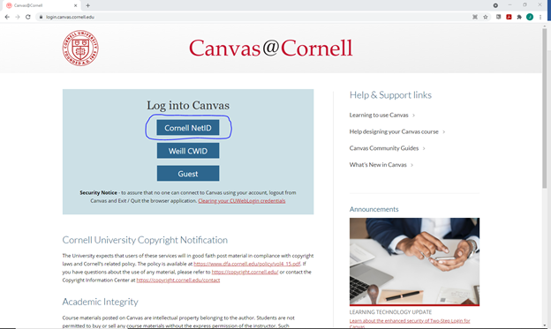

3. Click Courses

4. Select “CCSS Software Access”

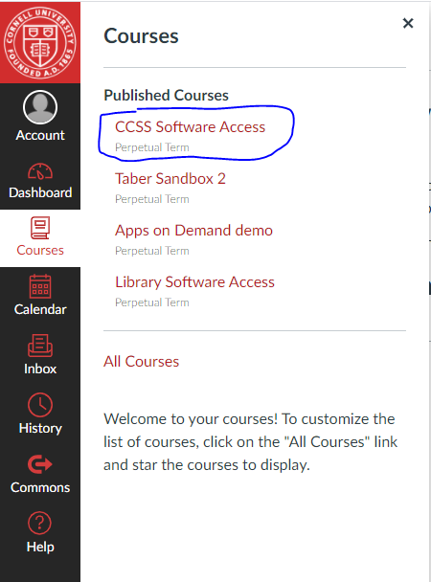

5. Once inside course select button “Apps on Demand - Statistics Software”. This will launch the resource where you can use the software

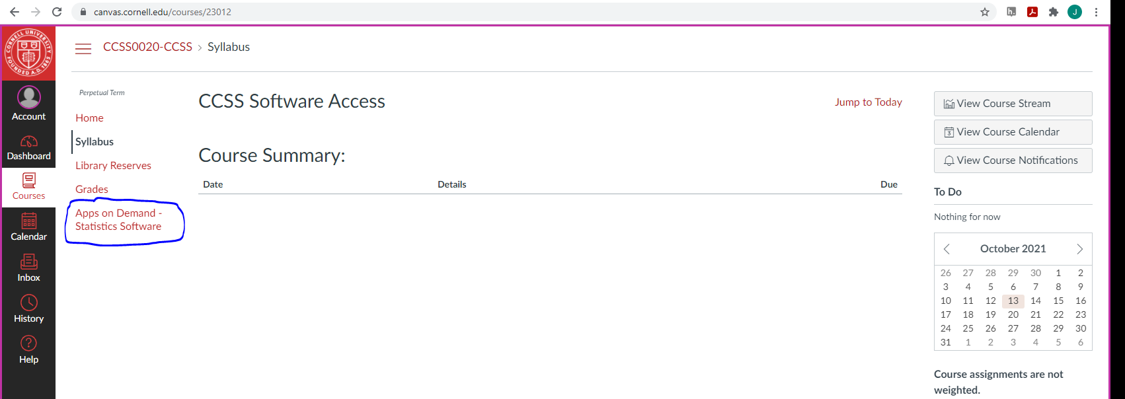

6. Select software

